# PIZZA SALES SQL QUERIES:

*By: Rajat Chourasiya*

Q1: Calculate the average order value:

SELECT SUM (total_price) / COUNT (DISTINCT order_id) as Avg_Order_Value from pizza_sales

Output:

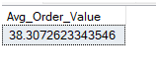

Q2: Calculate the total pizzas sold:

SELECT SUM (quantity) as Total_Pizza_Sold from pizza_sales

Output:

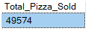

Q3. Determine total orders placed:

SELECT COUNT (DISTINCT order_id) as Total_orders from pizza_sales

Output:

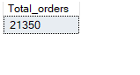

Q4: Determine average pizzas per order:

SELECT CAST (CAST (SUM (quantity) AS DECIMAL (10,2)) /

CAST (COUNT (DISTINCT order_id) AS DECIMAL (10,2)) AS DECIMAL (10,2)) AS Avg_pizza_per_order from pizza_sales

Output:

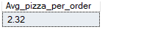

Q5. Observe Daily Trends for Total Orders:

SELECT DATENAME (DW, order_date) as order_day , COUNT(DISTINCT order_id) AS Total_orders from pizza_sales GROUP BY DATENAME (DW, order_date)

Output:

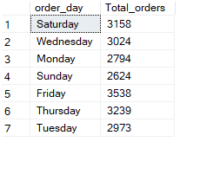

Q6. Observe Monthly Trends for Total Orders:

SELECT DATENAME (MONTH, order_date) as Month_Name, COUNT (DISTINCT order_id) AS Total_orders from pizza_sales GROUP BY DATENAME (MONTH, order_date)

Output:

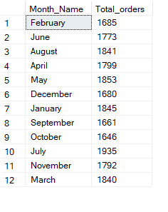

Q7: Total Orders placed Monthly in descending order:

SELECT DATENAME (MONTH, order_date) AS Month_Name, COUNT (DISTINCT order_id) AS

Total_orders FROM pizza_sales GROUP BY DATENAME (MONTH, order_date)

ORDER BY Total_orders DESC

Output:

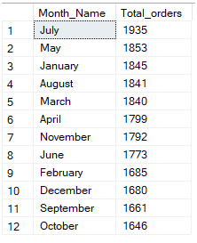

Q8. Determine percentage of sales by pizza category

SELECT pizza_category, SUM (total_price) as Total_Sales, SUM (total_price) * 100 /

(SELECT SUM (total_price) from pizza_sales) WHERE MONTH (order_date) =1) AS PCT

From pizza_sales

WHERE MONTH (order_date) = 1

GROUP BY pizza_category

Output:

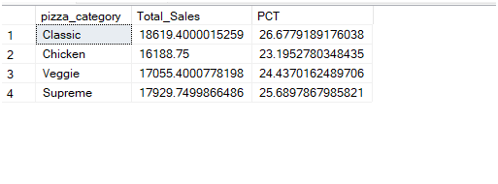

Q9. Top 5 Best Sellers by Revenue:

SELECT TOP 5 pizza_name, SUM (total_price) as Total_Revenue from pizza_sales

GROUP BY pizza_name

ORDER BY Total_Revenue DESC

Output:

